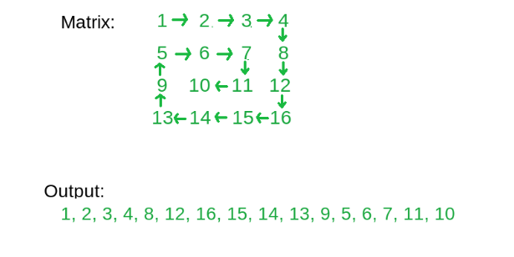MN

ZIG ZAG
1 2 3 4 8 7 6 5 9 10 11 12 13 14 15 16
R=0
While(r<m))
{
For (i=sc i<Ec i++)
A[r][i]
r++
if(r<m)
For (i=Ec-1 i>Sc i--)
A[r][i]
r++
}

- create and initilize variables k – starting row index, m – ending row index, l – starting column index, n – ending column index
- Run a loop until all the squares of loops are printed.
- In each outer loop traversal print the elements of a square in clockwise manner.
- Print the top row, i.e. Print the elements of kth row from column index l to n, and increase the count of k.
- Print the right column, i.e. Print the last column or n-1th column from row index k to m and decrease the count of n.
- Print the bottom row, i.e. if k > m, then print the elements of m-1th row from column n-1 to l and decrease the count of m
- Print the left column, i.e. if l < n, then print the elements of lth column from m-1th row to k and increase the count of l.
void spiralPrint(int m, int n, int a[R][C])
{
int i, k = 0, l = 0;

/* k - starting row index
m - ending row index
l - starting column index
n - ending column index
i - iterator
*/

while (k < m && l < n) {
/* Print the first row from the remaining rows */
for (i = l; i < n; ++i) {
printf("%d ", a[k][i]);
}
k++;

/* Print the last column from the remaining columns */
for (i = k; i < m; ++i) {
printf("%d ", a[i][n - 1]);
}
n--;

/* Print the last row from the remaining rows */
if (k < m) {
for (i = n - 1; i >= l; --i) {
printf("%d ", a[m - 1][i]);
}
m--;
}

/* Print the first column from the remaining columns */
if (l < n) {
for (i = m - 1; i >= k; --i) {
printf("%d ", a[i][l]);
}
l++;
}
}
}

/* Driver program to test above functions */
int main()
{
int a[R][C] = { { 1, 2, 3, 4, 5, 6 },
{ 7, 8, 9, 10, 11, 12 },
{ 13, 14, 15, 16, 17, 18 } };

spiralPrint(R, C, a);
return 0;
}

